Sample MPP Programming Exam Questions

1. Lambda/Streams Question

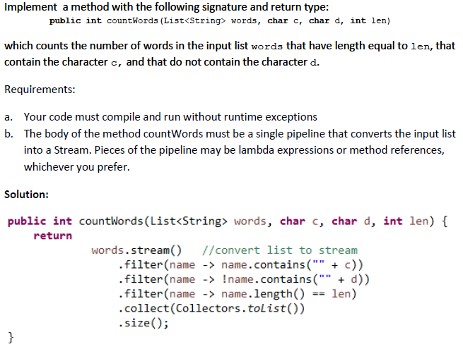

1. Uml-to-Code Problem. I do not have a sample of this yet, but it will be like Lab 4C (in the standard MPP course) but much easier. Students will receive a class diagram and (typically) a sequence diagram or two. They must translate the diagrams into Java code. There will be a computation that their code must perform, which involves the classes they have coded.